|  |  |
| --- | --- |
| Project name- GYM MEMBERSHIP  Submitted By: Sukhwinder Singh |  |

Table of Contents

Project Proposal 1

Goals and Objectives 1

Project Scope 2

Project Specifications 2

Target Audience 3

Project Tasks and Milestones 3

Resource Requirements 4

Analysis Report 4

Requirements Analysis 4

Detail Design 5

Home Page 5

Login Page 5

Trainers Page 6

Packages Page 6

Members Page 6

Registration Page 6

Project Testing 8

Testing 8

User Manual 9

Admin Setup 9

User Access Levels 9

# Project Proposal

## Goals and Objectives

The main aim of this project is to develop gym membership system. Users can register it and buy a new memership. Moreover, admin can add new machines and facilities and delete the existing . Also, admin can delete registration, can access the details of registrations. Admin has right to edit, delete and access details of the gym.

## Project Scope

This project is 4 weeks long which means 20 days of total to complete the project. The scope of this project is to help people to get gym membership

## Project Specifications

* Admin can login/logout successfully.
* Valid username and passwords are allowed
* Admin can add, edit, delete events.
* Admin can edit, delete and access details of participants
* Admin can delete and access the registration.

|  |  |  |  |  |  |  |  |  |  |  |  |  |  |  |  |
| --- | --- | --- | --- | --- | --- | --- | --- | --- | --- | --- | --- | --- | --- | --- | --- |
| **Stages** | **Activities** | **Duration**  **Week1-2** | | | | **Duration**  **Week-2-3** | | | | | **Duration**  **Week-3-4** | | | | |
| Project Planning | Research on gym |  |  |  |  |  |  |  |  |  |  |  |  |  |  |
| Project Proposal and documentation |  |  |  |  |  |  |  |  |  |  |  |  |  |  |
| Project Execution | Database Design |  |  |  |  |  |  |  |  |  |  |  |  |  |  |
| User Interface Design |  |  |  |  |  |  |  |  |  |  |  |  |  |  |
| Identity Framework implementation |  |  |  |  |  |  |  |  |  |  |  |  |  |  |
| Admin Interface |  |  |  |  |  |  |  |  |  |  |  |  |  |  |
| User Interface |  |  |  |  |  |  |  |  |  |  |  |  |  |  |
| Testing |  |  |  |  |  |  |  |  |  |  |  |  |  |  |
| Final | Documentation and final report |  |  |  |  |  |  |  |  |  |  |  |  |  |  |

* User can login/logout successfully,
* New User can register successfully
* User can participate in Events
* User can register for events and check details of the events.
* Admin can register new admin.

## Target Audience

The target audience for the gym above the 16 years .

## Project Tasks and Milestones

Project Tasks and Milestones are as below:

## Resource Requirements

Following technologies and development method:

* Asp.net MVC Framework and Identity framework- ASP
* Windows Operating System, 64-bit Processor and 4 to 8 GB RAM, MS Word

# Analysis Report

### Requirements Analysis

The requirement analysis covers the functional and non-functional aspects of the system.

#### Functional and Non-functional Requirements

|  |  |
| --- | --- |
| **Functional Requirements** | **Non-Functional Requirements** |
| Login/ Logout | The web app should work in all browsers and devices |
| Gym specifications add, update, edit, delete check detail as admin | Performance and load time should be fast |
| Features are delete and access by admin | Web app should be secure |
| Participants edit, delete and access by admin | Admin should have full access to the system |
| User can login/logout | Normal user should have limited access to the system. |
| User can register for gym membership and check details |  |

## Detail Design

### Home Page

This is main landing page of the Website. On the Navigation bar of this page there are menu options such as Home, Trainers, Packages, Members, Register and login.

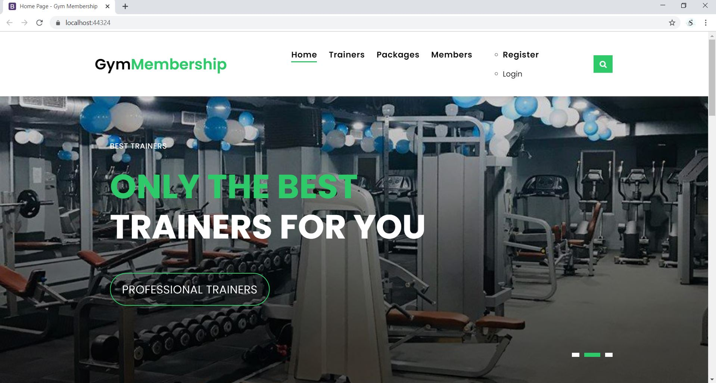

### Login Page

This Page is helpful for both Admin and users to login to the application by using their credentials.

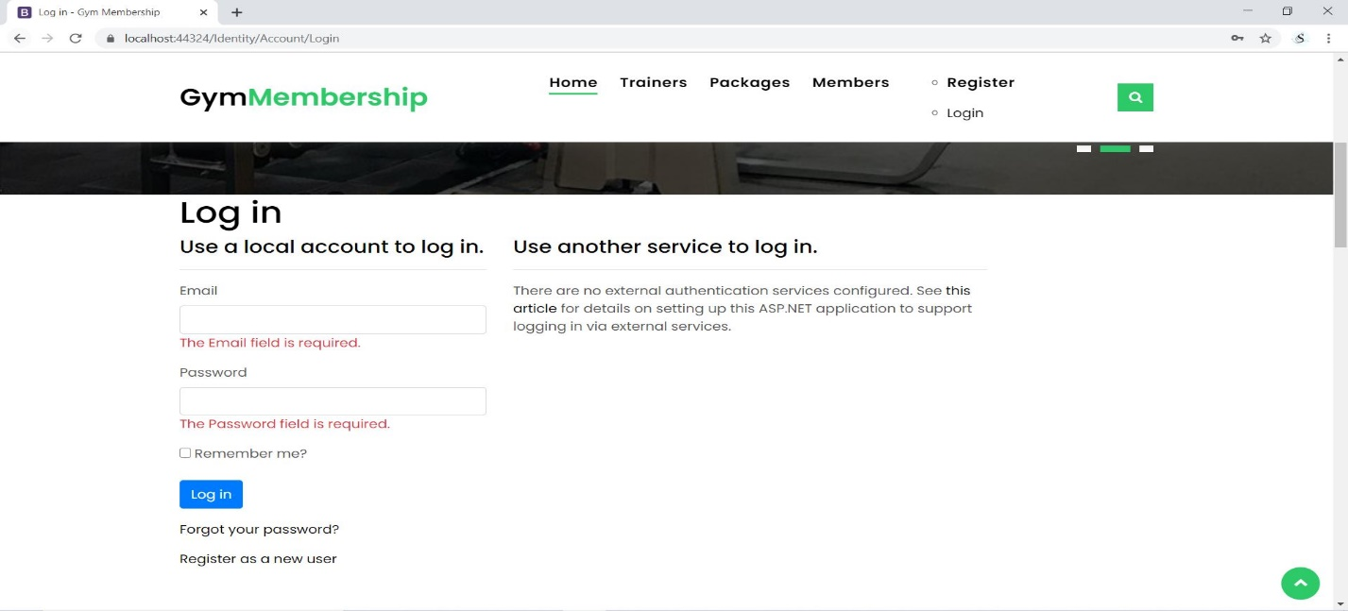

### Trainers Page

This page will highlight the details of all Trainers. An Admin can create new entries like age contact. Also, can edit and delete entries .

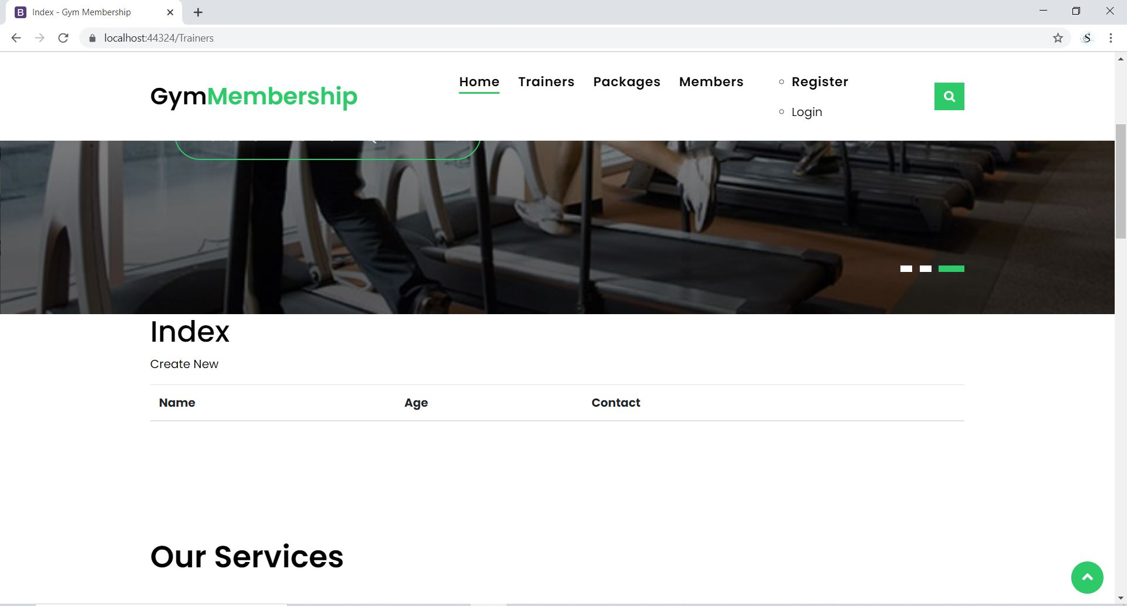

### Packages Page

With the help of this page admin can update the packages and prices about gym.

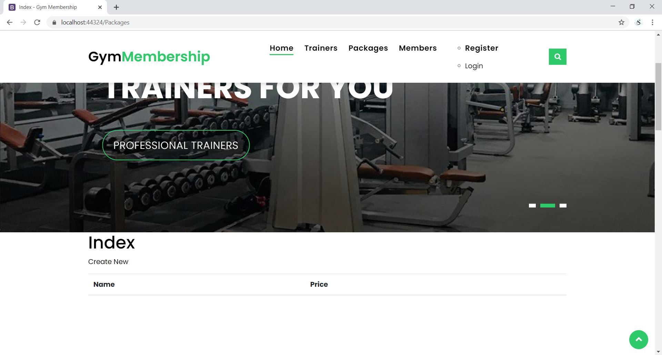

### Members Page

Members can update their information and their trainer as well. They will get the update about gym equipment and information in this page.

### 

### Registration Page

People can register themselves first and after that they access the update data in this website.

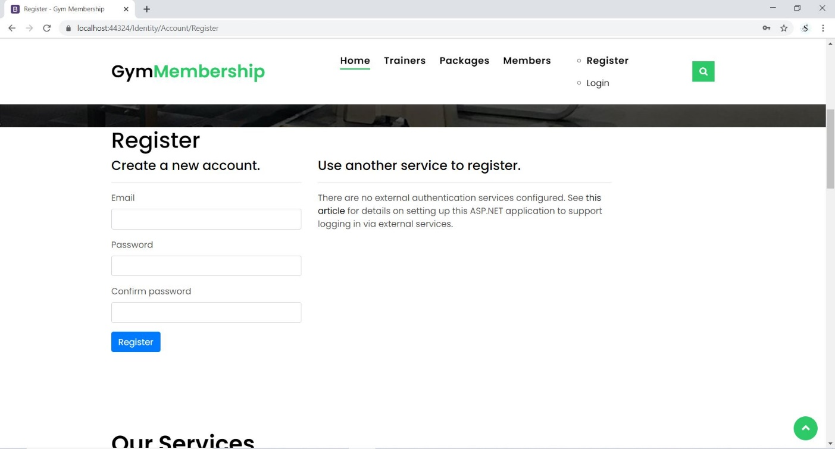

# Project Testing

### Testing

|  |  |  |  |  |  |  |
| --- | --- | --- | --- | --- | --- | --- |
| **Tester** | | **Scale** | | | | |
| **No.** | **Question** | **Strongly Disagree (1)** | **Disagree (2)** | **Normal (3)** | **Agree (4)** | **Strongly Agree (5)** |
| 1 | I will use the system frequently |  |  |  |  |  |
| 2 | I noticed that the different roles in this scheme were well integrated. |  |  |  |  |  |
| 3 | Is it Easy to use? |  |  |  |  |  |
| 4 | Most individuals will learn to use this device very easily. |  |  |  |  |  |
| 5 | Is the device intricate? |  |  |  |  |  |
| 6 | I thought there was too much inconsistency in this system |  |  |  |  |  |
| 7 | I believe that technical support is required to operate the system. |  |  |  |  |  |
| 8 | I found the system very bulky to use |  |  |  |  |  |
| 9 | I felt very confident using the system |  |  |  |  |  |
| 10 | I needed to learn a lot of things before I could get going with this system |  |  |  |  |  |

# User Manual

In “Gym membership” web app user can register for membership around and can book various gym and can check their details. New Users can register to access the information. Moreover, admin can add new equipment and announcement, edit and delete the existing information. Also, admin can delete registration and can access the details of registrations. Admin has right to edit, delete and access details of the participants.

### Admin Setup

* Admin needs to login using the valid credentials.
* If need to add a new admin, firstly the existing admin will login and register the new admin.

### User Access Levels

Only registered users can access the features of Meetup Application

* Admin: Full access to the system and all functionalities
* Users: Limited access to the app.